Q1. Describe the two categories of Image segmentation.

In [digital image processing](https://en.wikipedia.org/wiki/Digital_image_processing) and [computer vision](https://en.wikipedia.org/wiki/Computer_vision), **image segmentation** is the process of partitioning a [digital image](https://en.wikipedia.org/wiki/Digital_image) into multiple **image segments**, also known as **image regions** or **image objects** ([sets](https://en.wikipedia.org/wiki/Set_(mathematics)) of [pixels](https://en.wikipedia.org/wiki/Pixel)). The goal of segmentation is to simplify and/or change the representation of an image into something that is more meaningful and easier to analyze.[[1]](https://en.wikipedia.org/wiki/Image_segmentation#cite_note-computervision-1)[[2]](https://en.wikipedia.org/wiki/Image_segmentation#cite_note-2) Image segmentation is typically used to locate objects and [boundaries](https://en.wikipedia.org/wiki/Boundary_tracing) (lines, curves, etc.) in images. More precisely, image segmentation is the process of assigning a label to every pixel in an image such that pixels with the same label share certain characteristics.

Two types of image segmentation exist:

* **Semantic segmentation.**Objects shown in an image are grouped based on defined categories. For instance, a street scene would be segmented by “pedestrians,” “bikes,” “vehicles,” “sidewalks,” and so on.

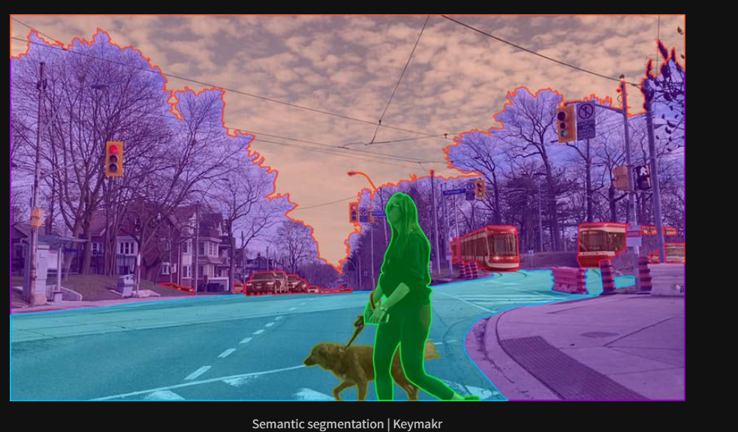

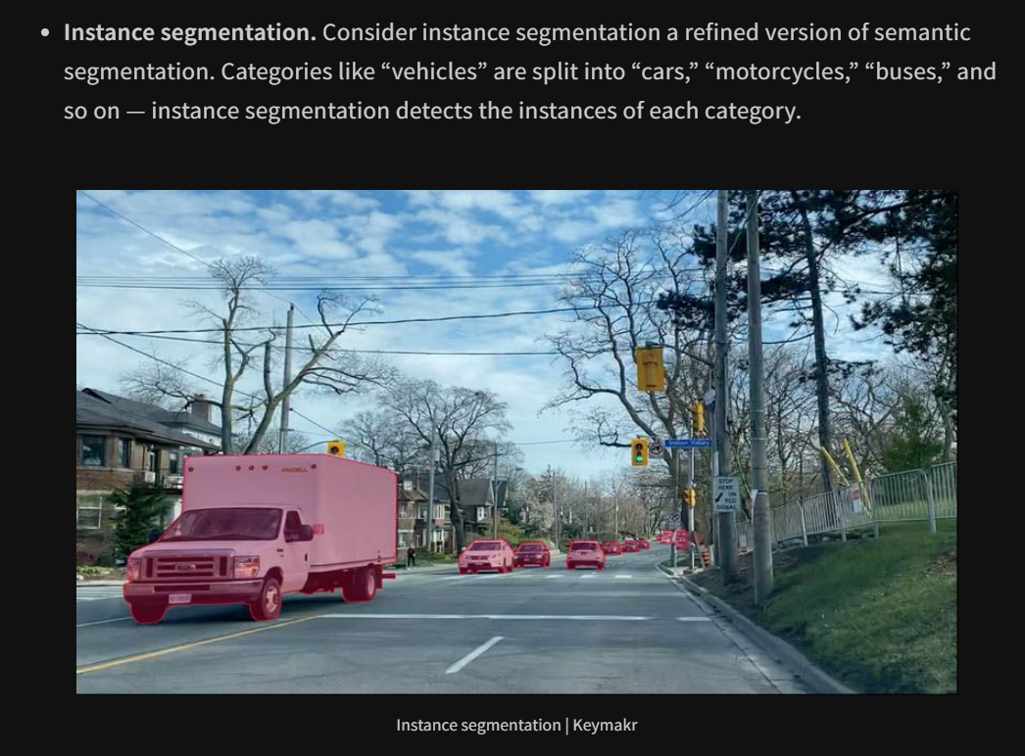

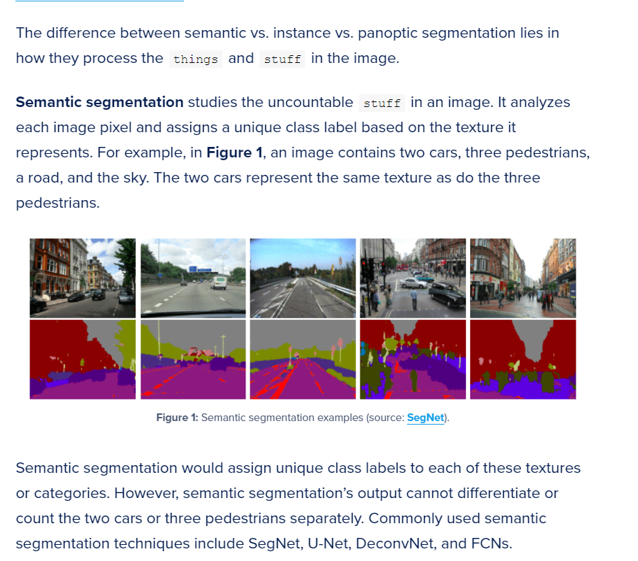

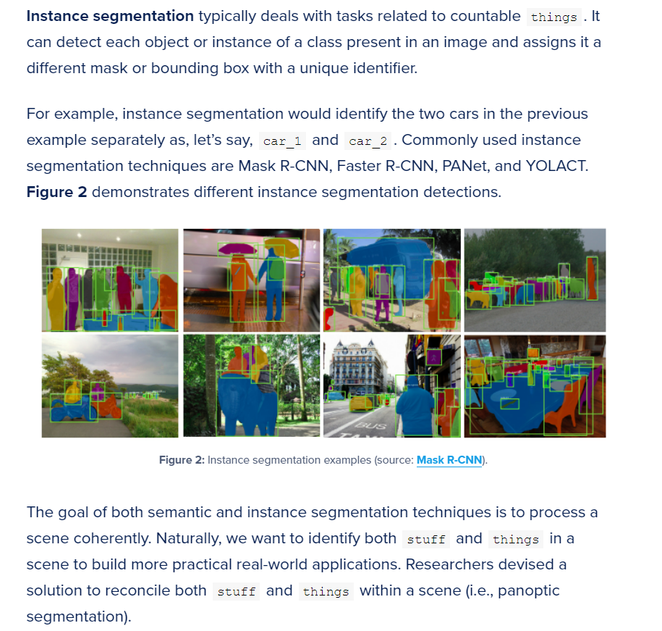

Q2.

Briefly explain the different approaches for image segmentation.

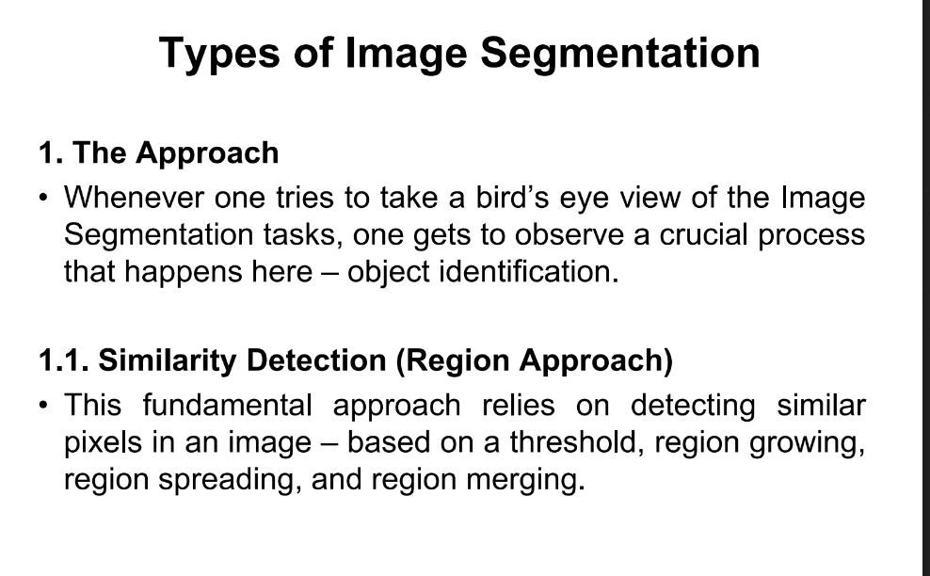

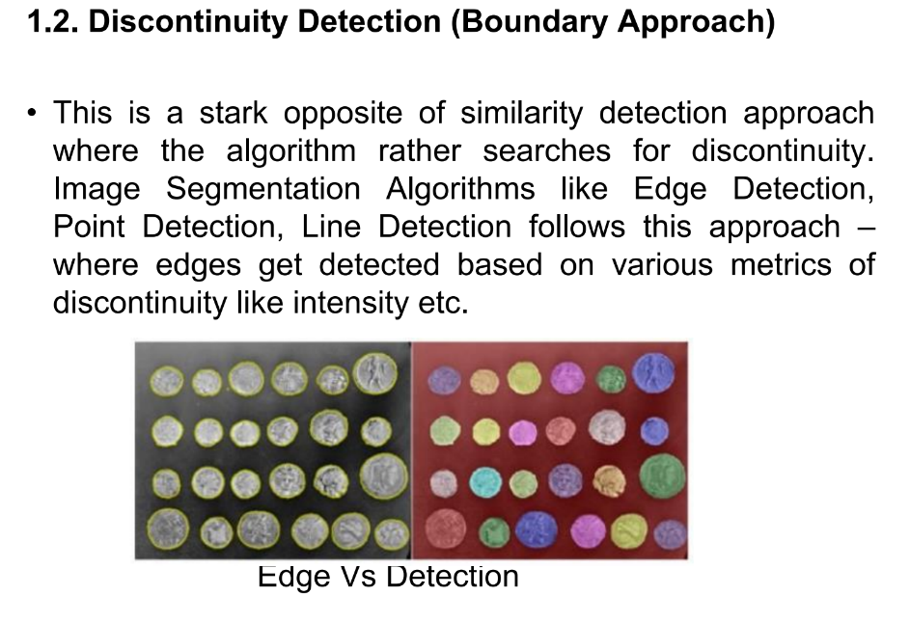

Q3. Illustrate the segmentation methods based on points, lines and edges

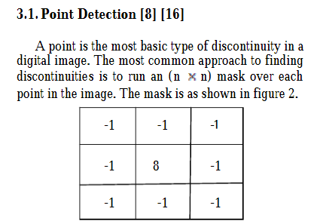

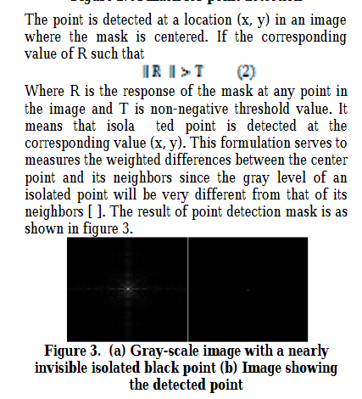

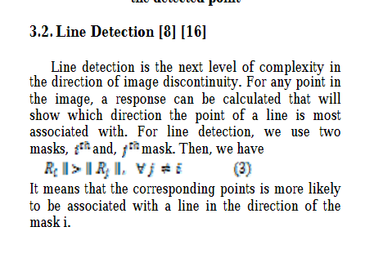

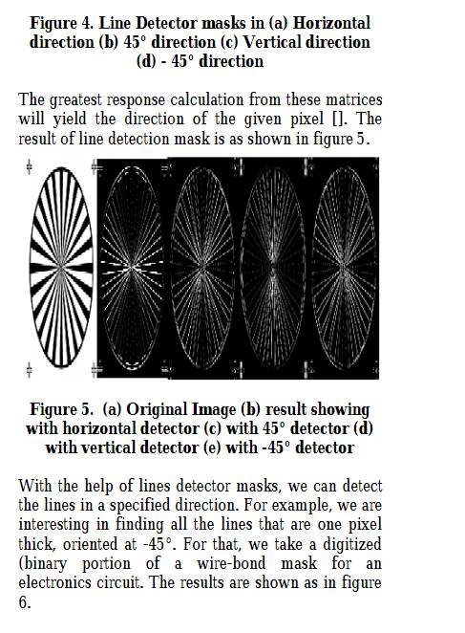

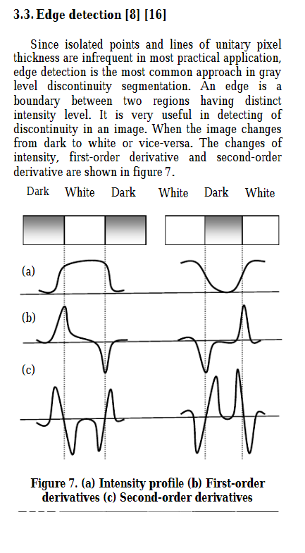

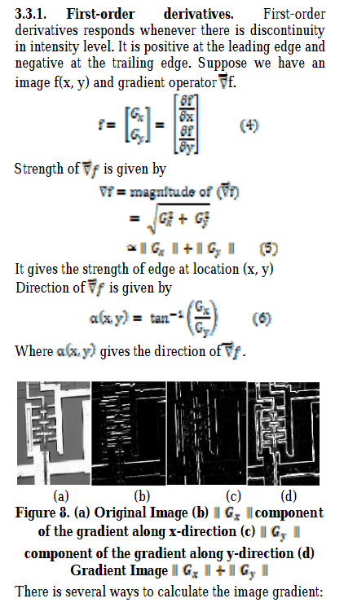

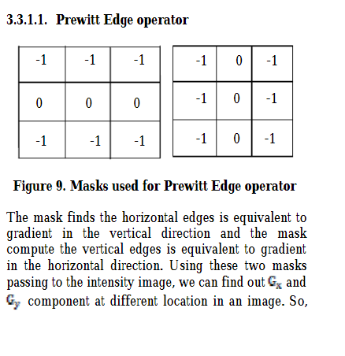

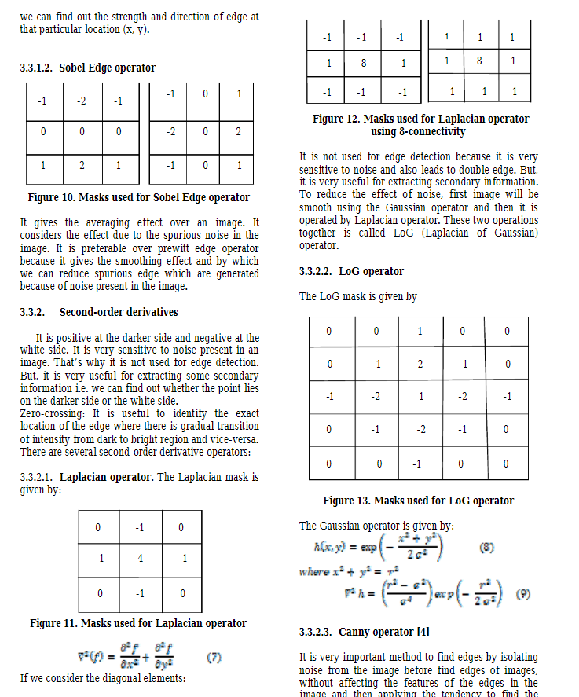

q5. Describe any one algorithm used for edge detection.

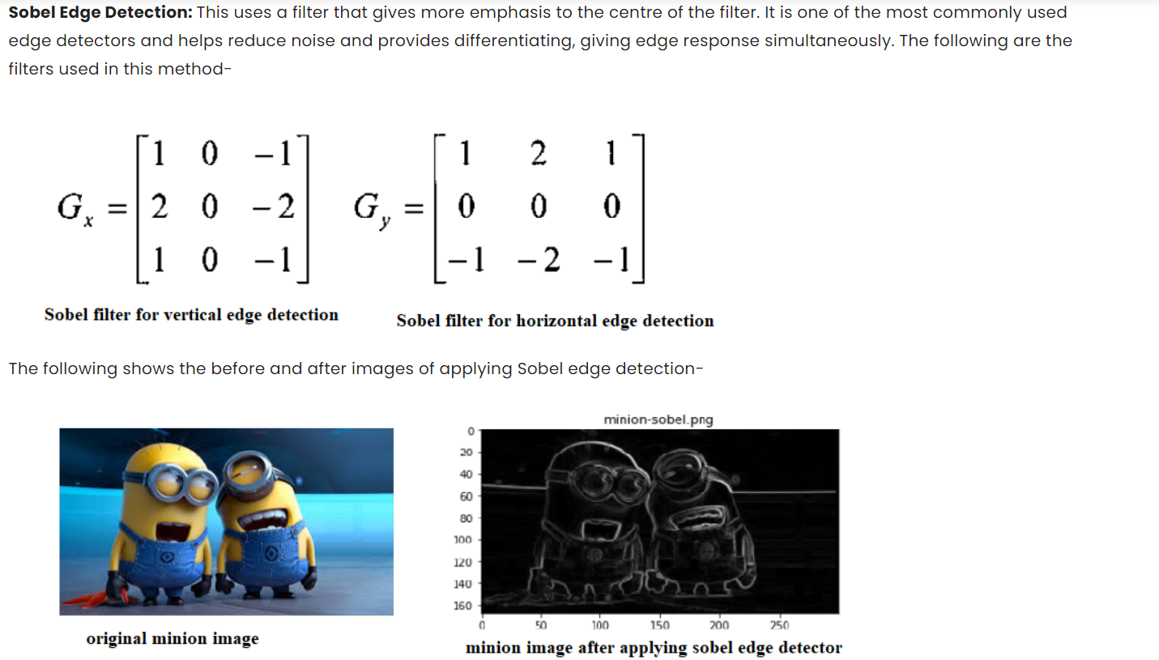

6. Define thresholding and explain the various techniques of thresholding in detail.

Image thresholding is a simple form of image segmentation. It is a way to create a binary image from a grayscale or full-color image. This is typically done in order to separate "object" or foreground pixels from background pixels to aid in image processing.

Image thresholding is the easiest way to separate image background and foreground. Also, this image thresholding can be identify as image segmentation. To apply thresholding techniques, we should use a gray scale image. When thresholding, that grayscale image will be converted to a binary image. In this article, we will discuss about different types of digital image thresholding techniques.

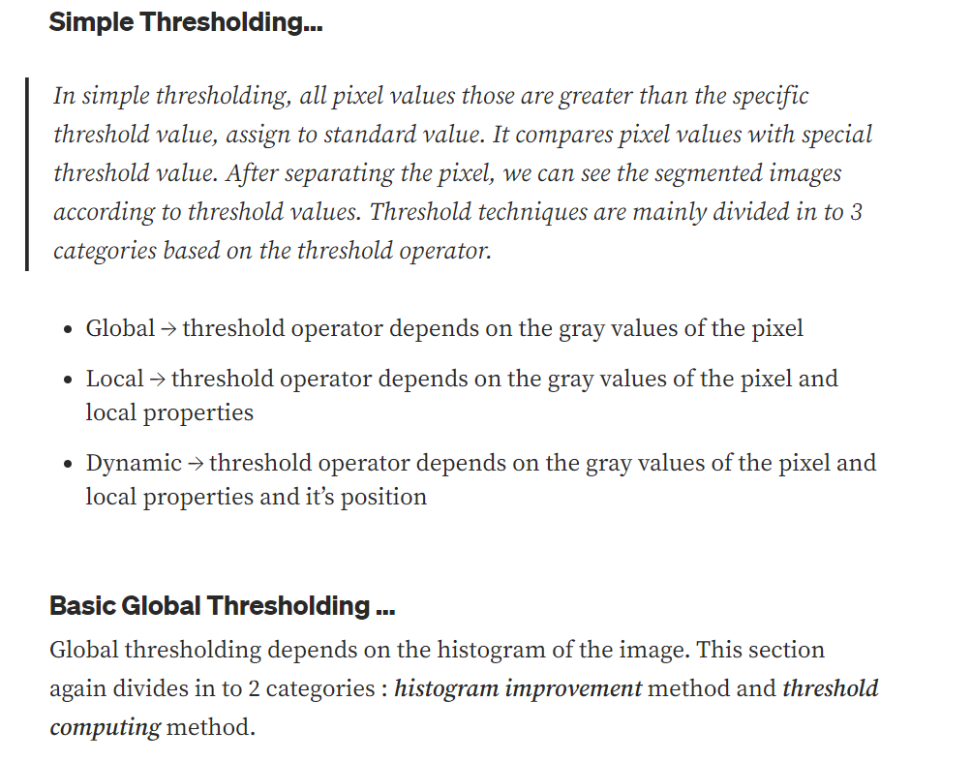

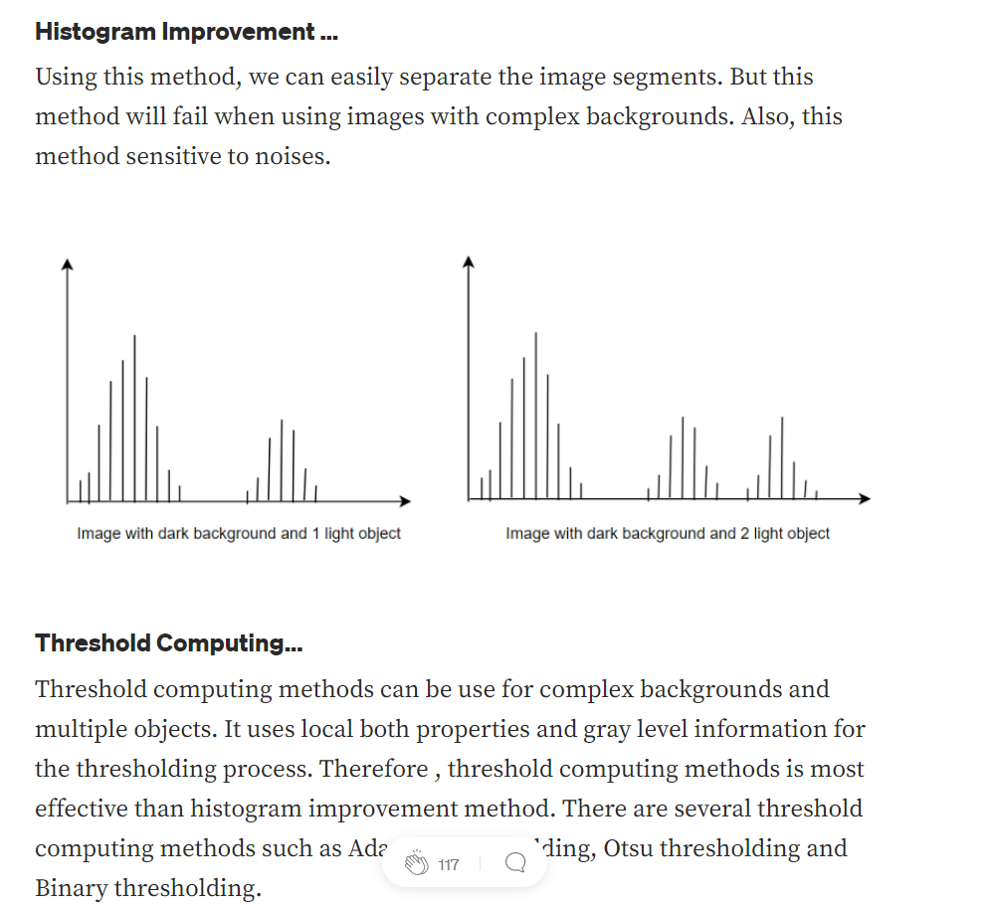

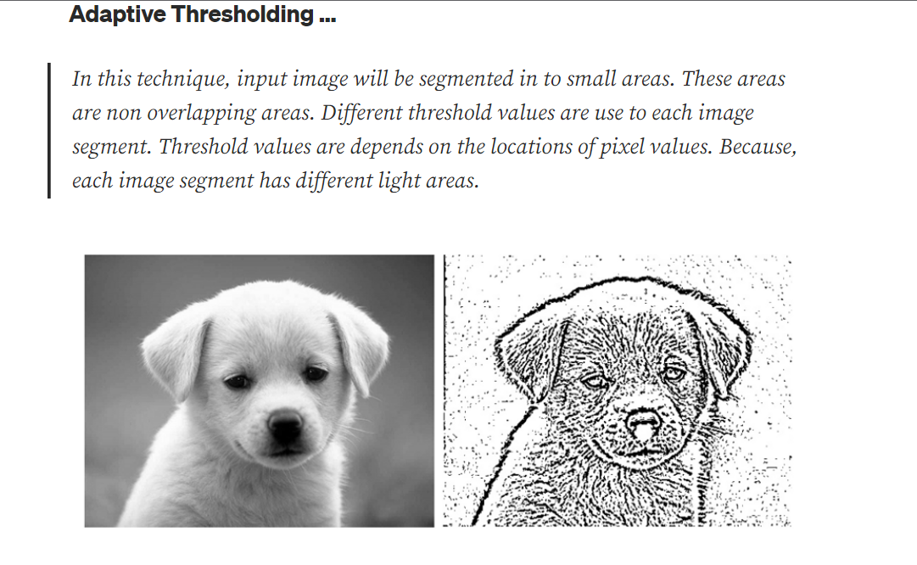

**Truncate Thresholding …**

In this method, the destination pixel will be set to the threshold value. Pixel values which are greater than the threshold value will be set to threshold value. Other values are remaining same.

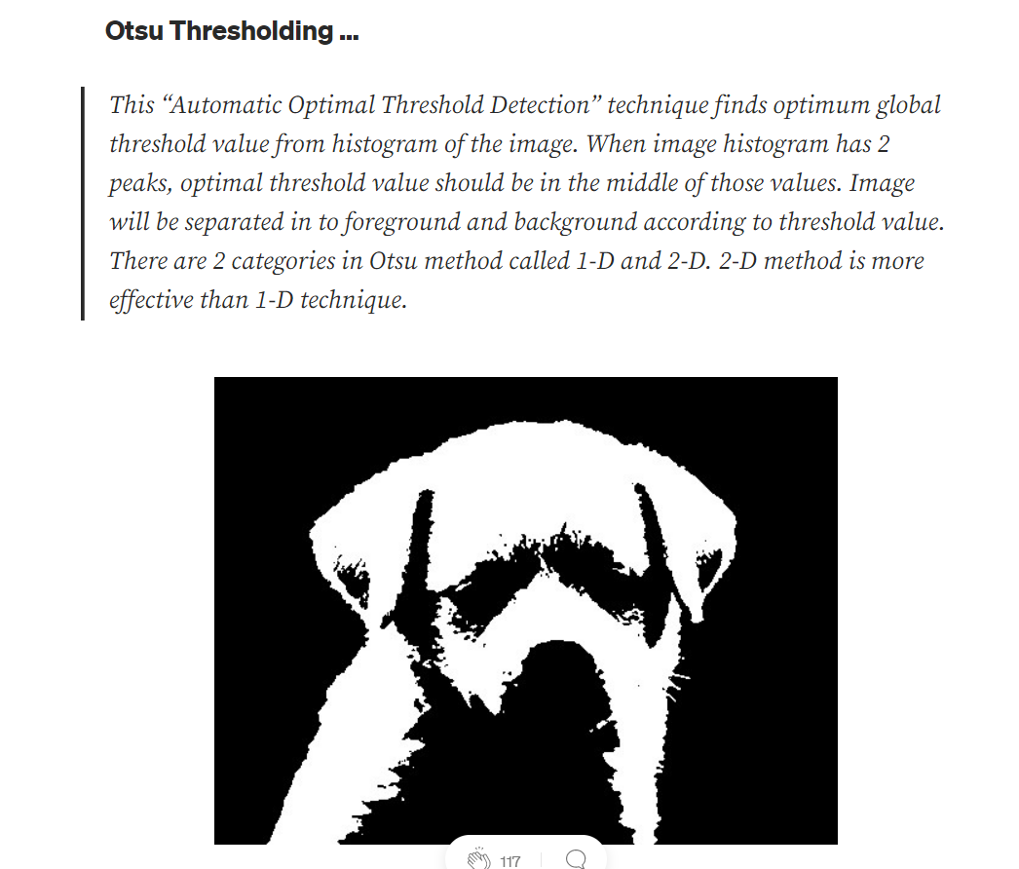

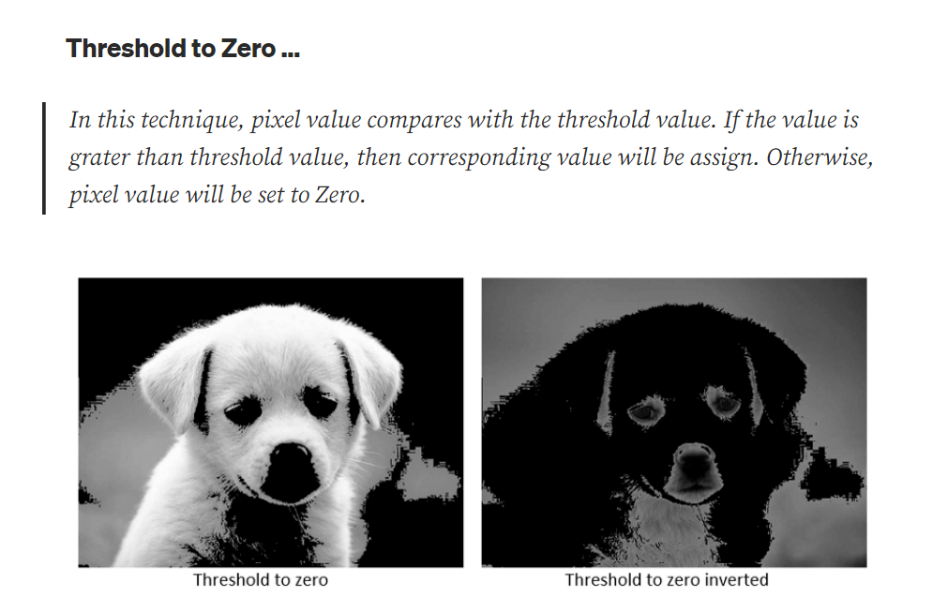

q7. Discuss the different region based image segmentation techniques.

### Region-Based Segmentation

In this segmentation, we grow regions by recursively including the neighboring pixels that are similar and connected to the seed pixel. We use similarity measures such as differences in gray levels for regions with homogeneous gray levels. We use connectivity to prevent connecting different parts of the image.

There are two variants of region-based segmentation:

* **Top-down approach**
  + First, we need to define the predefined seed pixel. Either we can define all pixels as seed pixels or randomly chosen pixels. Grow regions until all pixels in the image belongs to the region.
* **Bottom-Up approach**
  + Select seed only from objects of interest. Grow regions only if the similarity criterion is fulfilled.
* **Similarity Measures:**
  + Similarity measures can be of different types: For the grayscale image the similarity measure can be the different textures and other spatial properties, intensity difference within a region or the distance b/w mean value of the region.
* **Region merging techniques:**
  + In the region merging technique, we try to combine the regions that contain the single object and separate it from the background.. There are many regions merging techniques such as Watershed algorithm, Split and merge algorithm, etc**.**
* **Pros:**
  + Since it performs simple threshold calculation, it is faster to perform.
  + Region-based segmentation works better when the object and background have high contrast.
* **Limitations:**
  + It did not produce many accurate segmentation results when there are no significant differences b/w pixel values of the object and the background.

9. Define image feature? How are the features classified?

Features are parts or patterns of an object in an image that

help to identify it.

Feature extraction is a process of dimensionality reduction

by which an initial set of raw data is reduced to more

manageable groups for processing. A characteristic of

these large data sets is a large number of variables that

require a lot of computing resources to process.

Feature Extraction is an important technique in Computer

Vision widely used for tasks like:

• Object recognition

• Image alignment and stitching (to create a panorama)

• 3D stereo reconstruction

• Navigation for robots/self-driving cars

**Classification**

There are several types of classification:

|  |  |  |
| --- | --- | --- |
| **Type of Classification** | **Description** | **Example** |
| **Categorical (Nominal)** | Classification of entities into particular categories. | That thing is a dog.  That thing is a car. |
| **Ordinal** | Classification of entities in some kind of ordered relationship. | You are stronger than him.  It is hotter today than yesterday. |
| **Adjectival or Predicative** | Classification based on some quality of an entity. | That car is fast.  She is smart. |
| **Cardinal** | Classification based on a numerical value. | He is six feet tall.  It is 25.3 degrees today. |

1)Character level features: Computerized handwriting identification

consist of two type of handwriting features macro and micro. Macro

features are gray scale based , contour based, slope stroke-width, slant

and height.

2) The structural features representing the coarser shape of the

character capture the presence of corners, diagonal lines, and vertical

and horizontal lines in the gradient image.

3) The concavity features capture the major topological and geometrical

features including direction of bays, presence of holes, and large

vertical and horizontal strokes.

4) Micro features (GSC) are found to be discriminating for the writers.

Furthermore, they found ’G’, ’b’, ’N’, ’I’, ’K’, ’J’,’W’, ’D’, ’h’, ’f’ are the 10

most discriminating characters.

10. Discuss the classification of feature extraction in Image processing

# Image Feature Extraction class work

Part 2

11. Define Representation. Explain two types of Image representation with an example.

Abstract—Image Representation is the process of generating descriptions from the visual contents of an image. There is a wide range of image representation methods which have been proposed in the past few decades. Some of these methods are designed for specific application areas while others are more generalized and can be applied in various fields. Each of the image representation methods is unique in its own way and has its advantages and drawbacks. This paper does a brief review on different existing two dimensional image representation methods by focusing its approach, advantages, limitations and applications. The analysis shows that most of the representations is based on machine perception model which cannot be understandable by a human being just by looking through his eyes. The paper ends with the suggestion of introducing a representation which can understandable by both a human and machine.

III. CLASSIFICATIONS ON IMAGE REPRESENTATIONS Image Representation is the foundation of good performance of various image processing tasks. To represent each image effectively a large number of image representation methods have been proposed over the time [8]. And these image representation methods can be classified on the basis of three parameters: (1) Based on level of processing (2) Based on level of abstraction (3) Based on image features.

3. Region based representations: Also known as superpixel representation. Here the regions are not rectangular and it is formed by grouping similar and connected pixels. The adjacency information between regions is represented usually as RAG(region-adjacency graph) or combinatorial map. The representation is used for object detection and segmentation, but different unions of multiple regions have to be considered [9]

12.Explain Chain Code with an example.

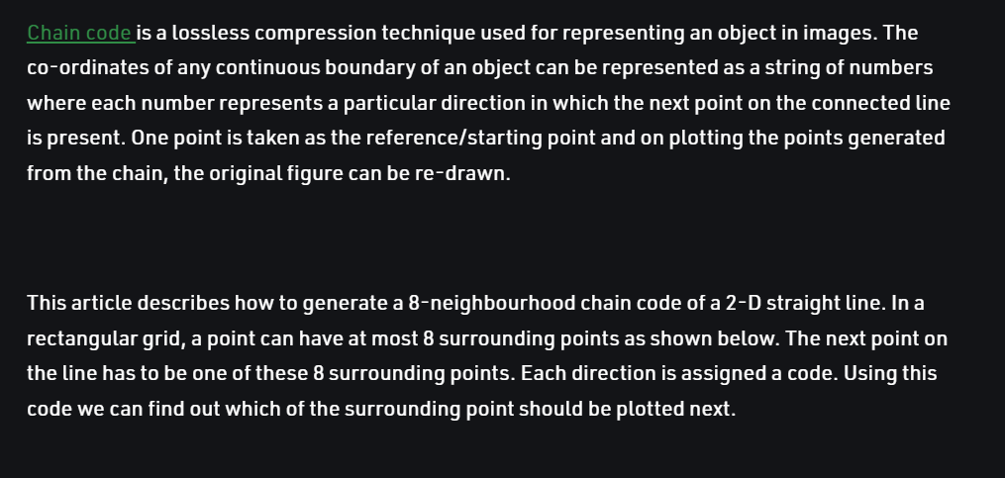

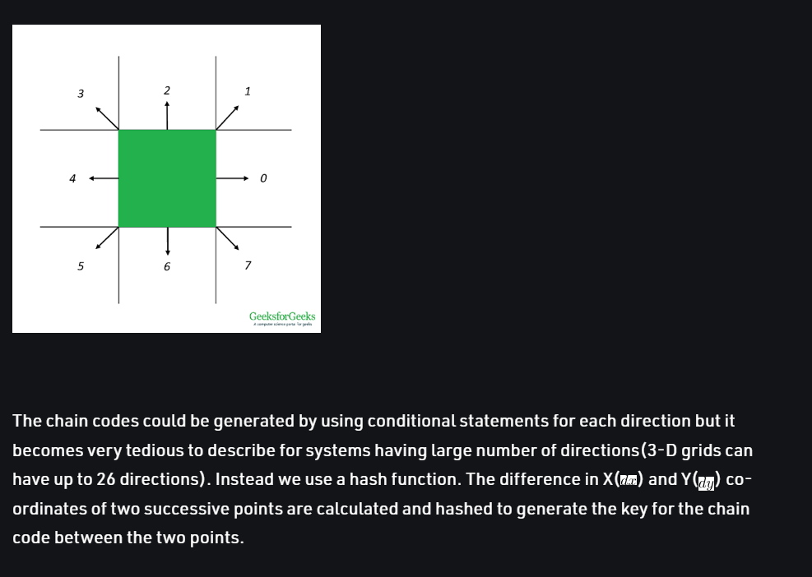

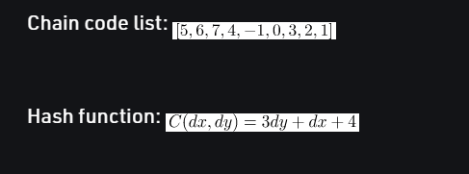

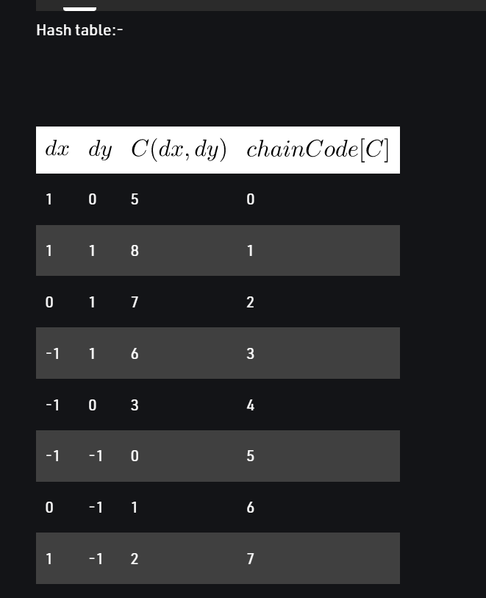

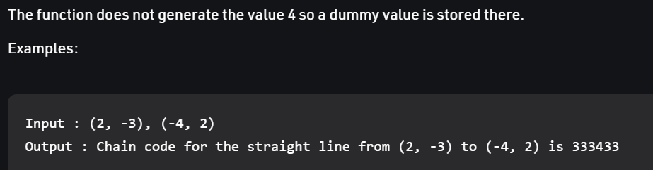

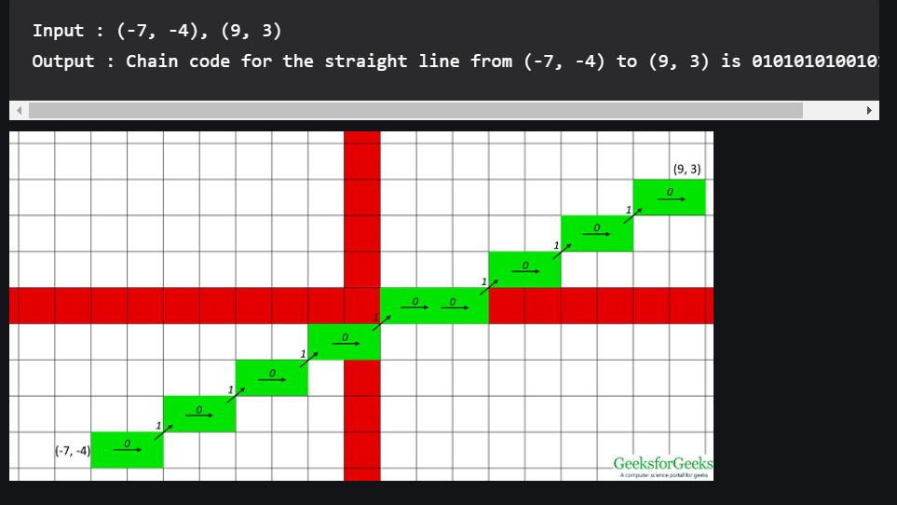

13.Discuss Fourier Descriptors of the boundary. What are the properties of Fourier Descriptors?

**Fourier descriptors** A method used in object recognition and [image processing](https://www.encyclopedia.com/science-and-technology/computers-and-electrical-engineering/computers-and-computing/image#1O11imageprocessing) to represent the boundary shape of a [segment](https://www.encyclopedia.com/science-and-technology/computers-and-electrical-engineering/computers-and-computing/segment#1O11segment) in an image. The first few terms in a [Fourier series](https://www.encyclopedia.com/science-and-technology/mathematics/mathematics/fourier-analysis#1O11Fourierseries) provide the basis of a [descriptor](https://www.encyclopedia.com/computing/dictionaries-thesauruses-pictures-and-press-releases/descriptor). This type of object descriptor is useful for recognition tasks because it can be designed to be independent of scaling, translation, or rotation.

**Fourier Transform:** Fourier transform is the input tool that is used to decompose an image into its sine and cosine components.

**Linearity:**  
Addition of two functions corresponding to the addition of the two frequency spectrum is called the linearity. If we multiply a function by a constant, the Fourier transform of the resultant function is multiplied by the same constant. The Fourier transform of sum of two or more functions is the sum of the Fourier transforms of the functions

**Scaling:**  
Scaling is the method that is used to the change the range of the independent variables or features of data. If we stretch a function by the factor in the time domain then squeeze the Fourier transform by the same factor in the frequency domain.

**Differentiation:**  
Differentiating function with respect to time yields to the constant multiple of the initial function.

**Convolution:**  
It includes the multiplication of two functions. The Fourier transform of a convolution of two functions is the point-wise product of their respective Fourier transforms.

**Frequency Shift:**  
Frequency is shifted according to the co-ordinates. There is a duality between the time and frequency domains and frequency shift affects the time shift.

**Time Shift:**  
The time variable shift also effects the frequency function. The time shifting property concludes that a linear displacement in time corresponds to a linear phase factor in the frequency domain.

14.Write short notes on Image representation:

a. Using boundary descriptors b. Using regional descriptors

BOUNDARY DESCRIPTORS

**Simple Descriptors**

● Length of a Contour By counting the number of pixels along the contour. For a chain coded curve with unit spacing in both directions, the number of vertical and horizontal components plus 21/2 times the number of components give the exact length of curve

. ● Boundary Diameter It is defines as Diam (B) = max [D(pi , pj)] i, j where D is the distance measure which can be either Euclidean distance or D4 distance. The value of the diameter and the orientation of the major axis of the boundary are two useful Descriptors.

**BOUNDARY DESCRIPTORS**

● Curvature It is the rate of change of slope. Curvature can be determined by using the difference between the slopes of adjacent boundary segments at the point of intersection of the segments. Shape Numbers Shape number is the smallest magnitude of the first difference of a chain code representation. The order of a shape number is defined as the number of digits in its representation. Shape order is even for a closed boundary.

**REGIONAL DESCRIPTORS** Simple Descriptors Area, perimeter and compactness are the simple region Descriptors Compactness = (perimeter)2/area

Topological Descriptors ● Rubber-sheet Distortions Topology is the study of properties of a figure that are unaffected by any deformation, as long as there is no tearing or joining of the figure. ● Euler Number Euler number (E) of region depends on the number of connected components (C) and holes (H). E = C − H A connected component of a set is a subset of maximal size such that any two of its points can be joined by a connected curve lying entirely within the subset.

<https://www.ecb.torontomu.ca/~gnkhan/Computer-Vision/Lectures/Image-Rep.pdf> link